Skill Session 3

Task 1
DML: SELECT, INSERT, UPDATE, DELETE; parameterised queries to prevent SQL injection · JOINs (INNER, LEFT, RIGHT, FULL, CROSS, SELF); subqueries; CTEs (WITH clause)
CREATE DATABASE
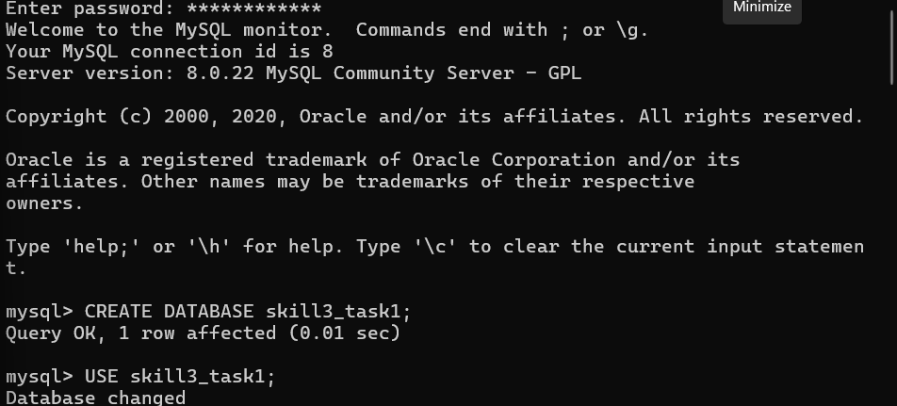
CREATE TABLES
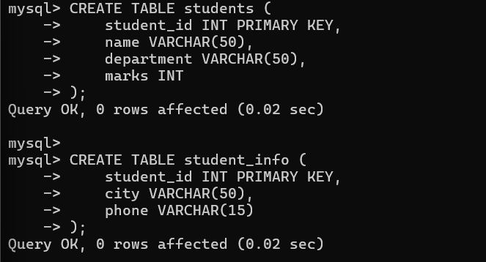
INSERT
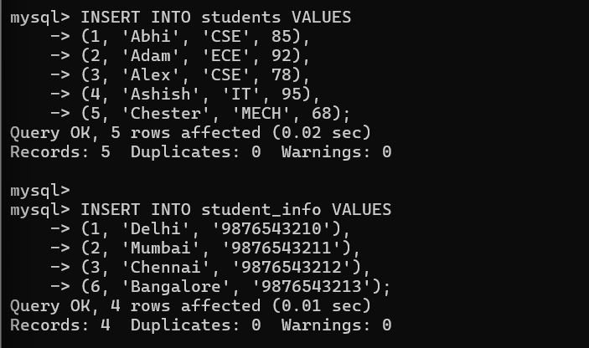
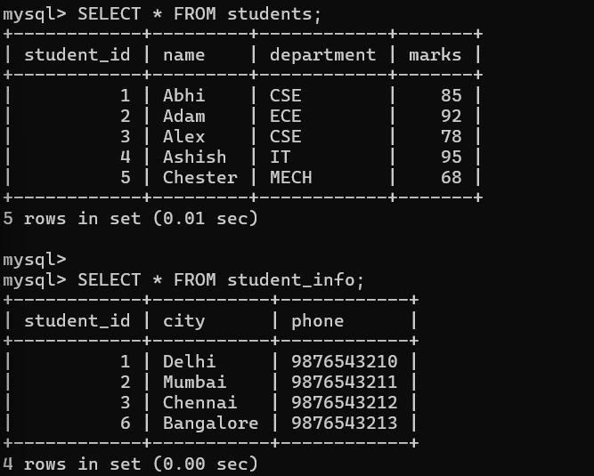
SELECT
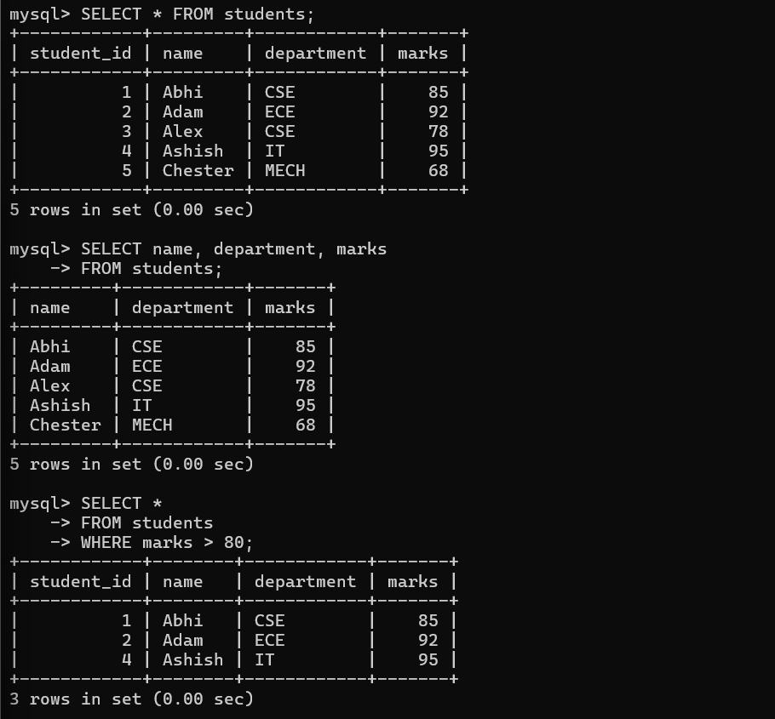
UPDATE
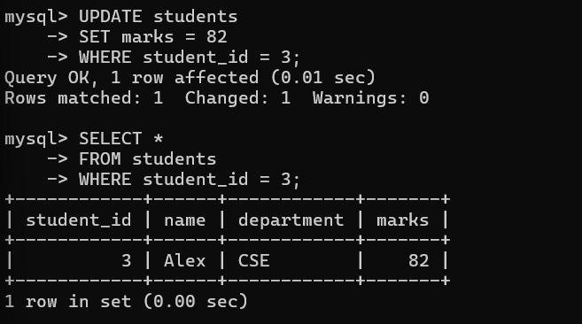
DELETE
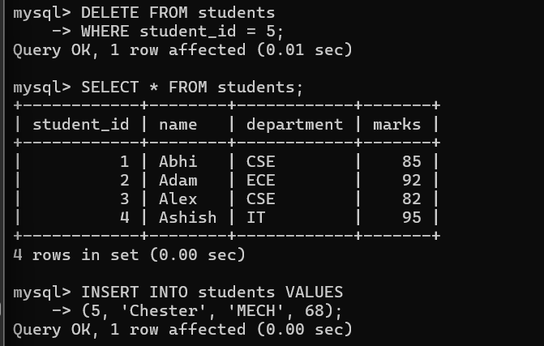
PARAMETERISED QUERY
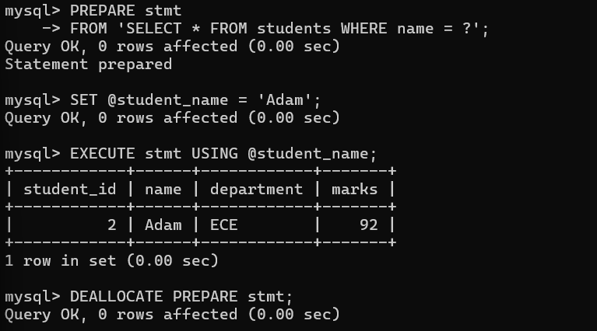
SQL INJECTION PREVENTION
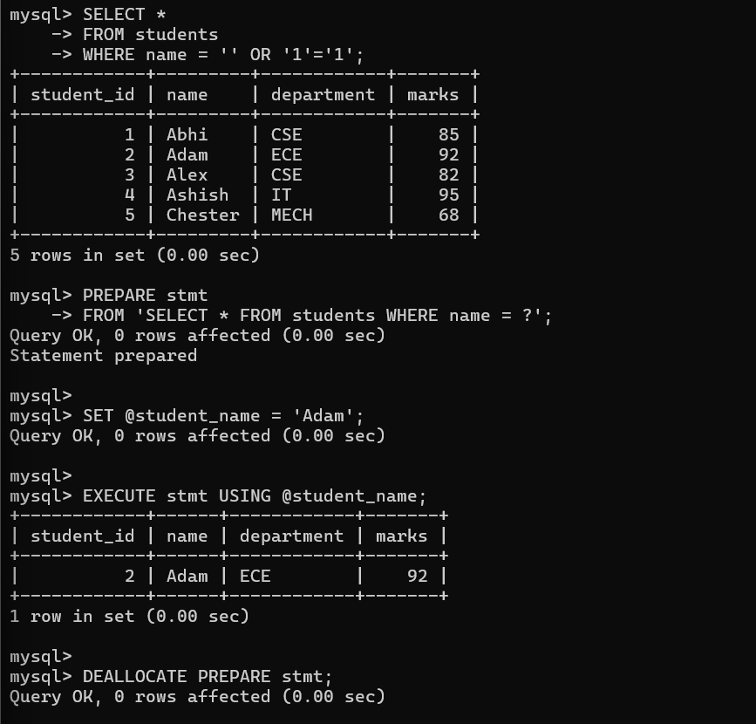
INNER JOIN
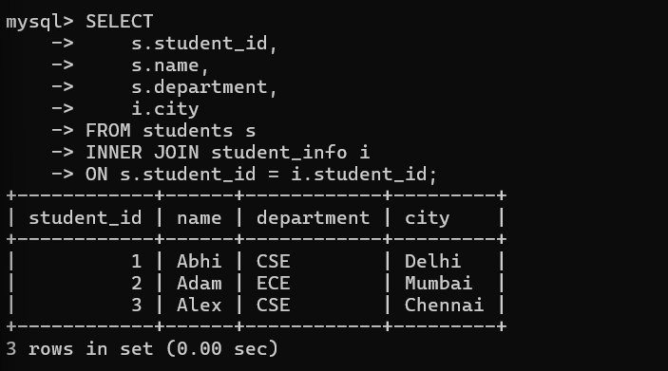
LEFT JOIN
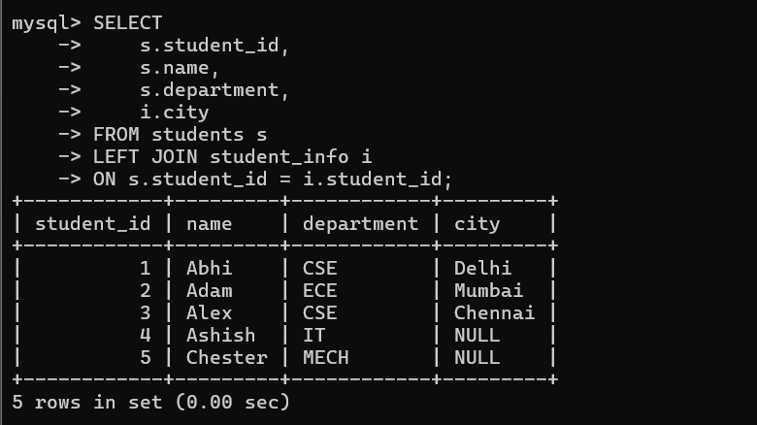
RIGHT JOIN
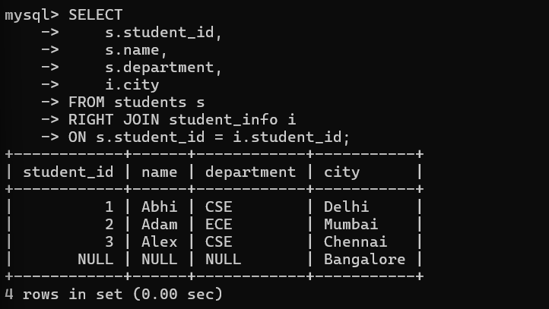
FULL JOIN
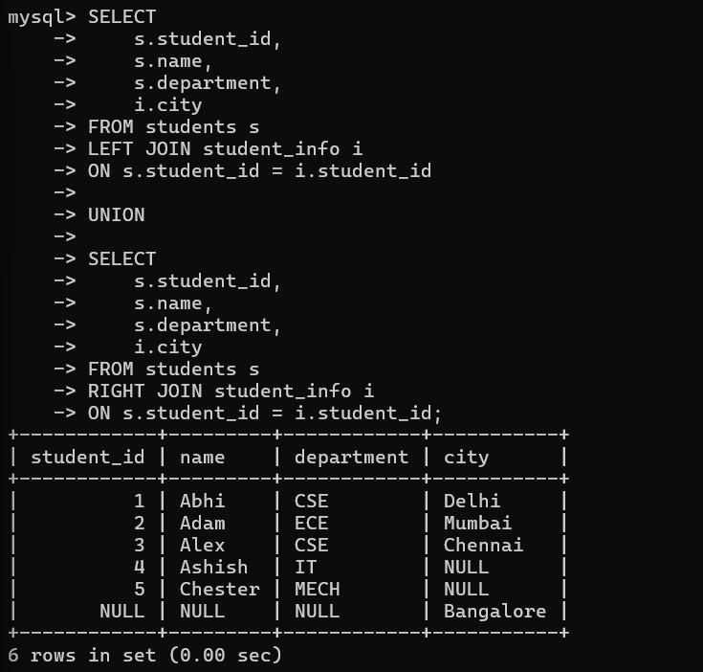
CROSS JOIN
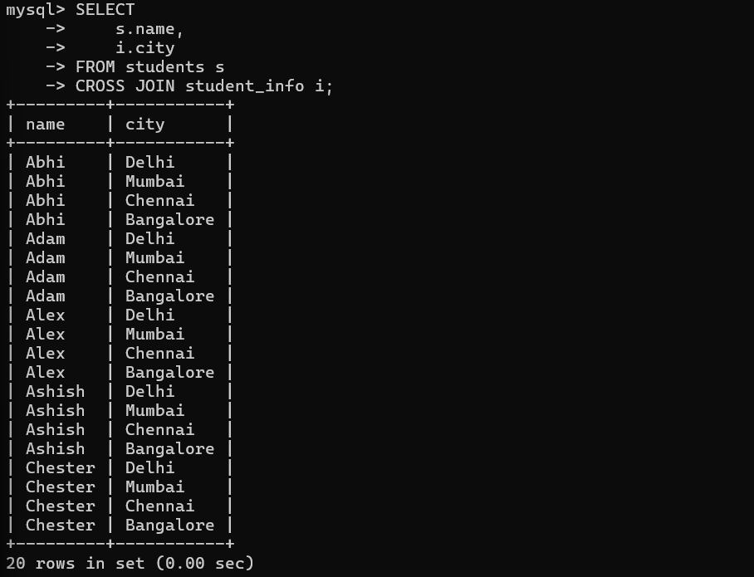
SELF JOIN
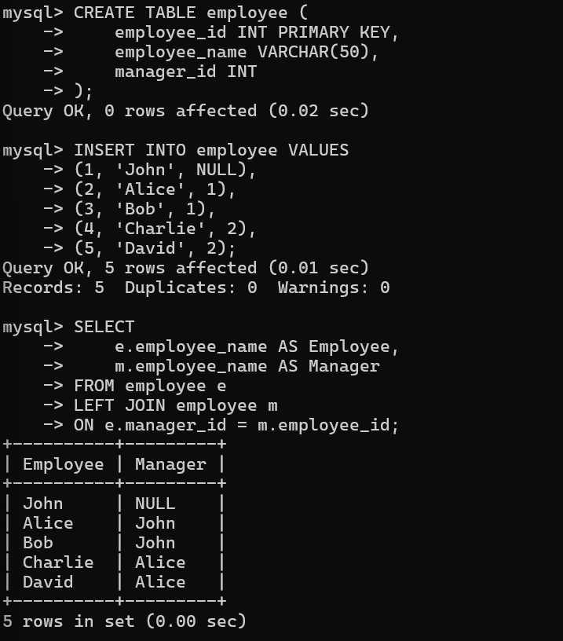
SUBQUERY
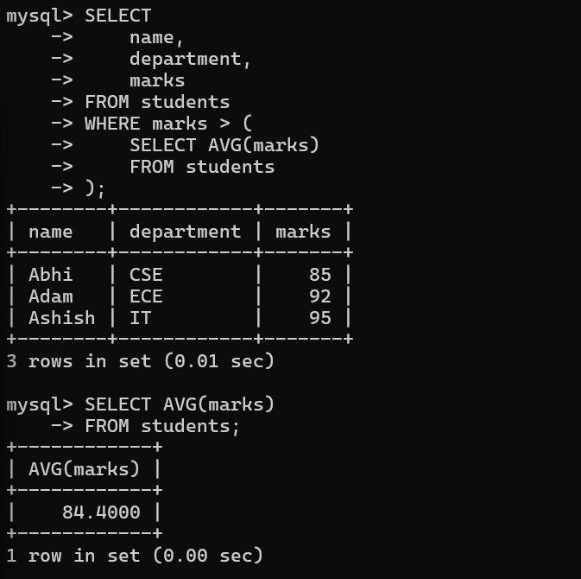
ANOTHER SUBQUERY — MAX MARKS
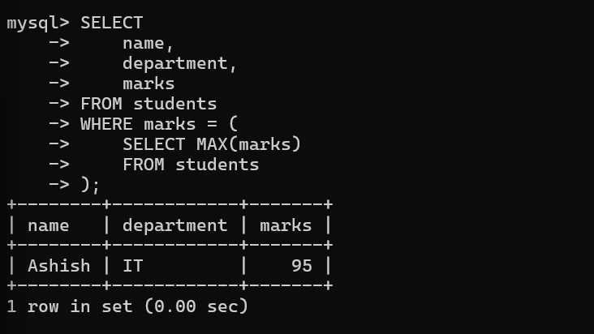
CTE — WITH CLAUSE
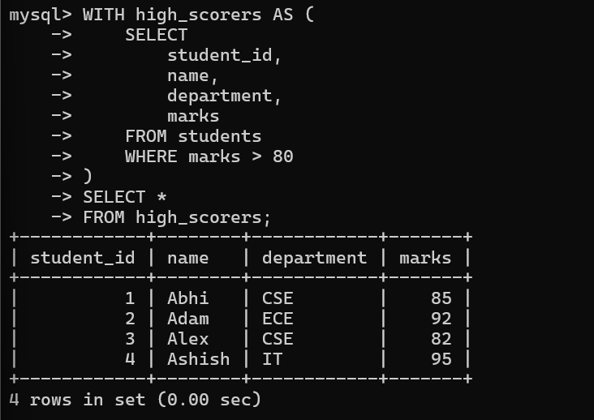
CTE + GROUP BY
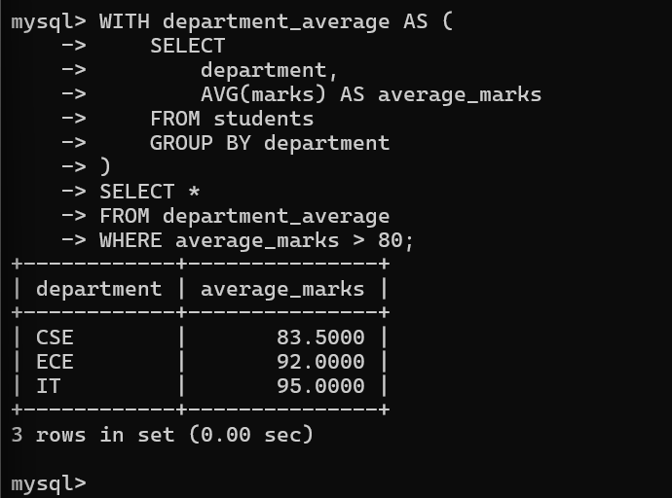

Task 2
Aggregate functions; GROUP BY / HAVING; window functions: ROW_NUMBER, RANK, LAG, LEAD · CASE expressions; JSONB operators (->>); UNION / INTERSECT / EXCEPT · PBL: Write 12+ queries matching all frontend dashboard and listing requirements
AGGREGATE FUNCTIONS
- Count
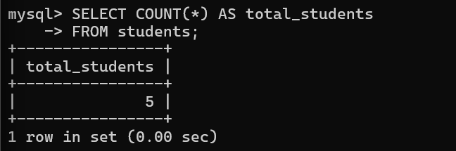
- Sum
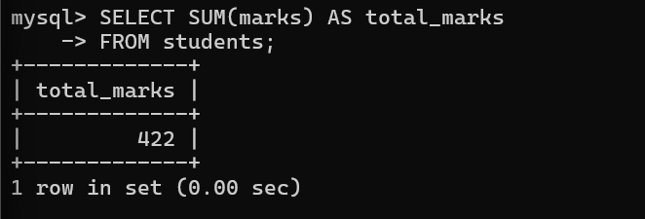
- Avg
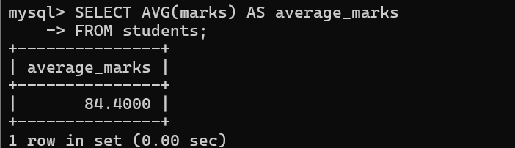
- Max
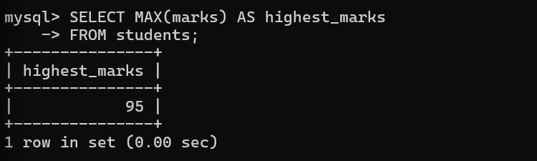

- Min
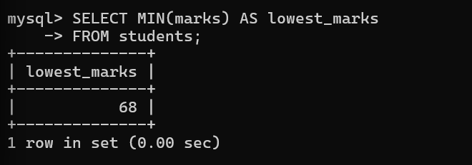
GROUP BY
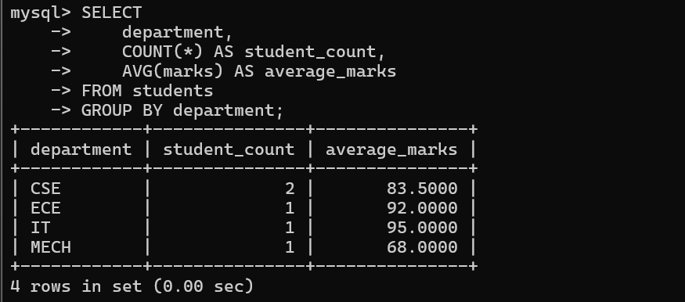
HAVING
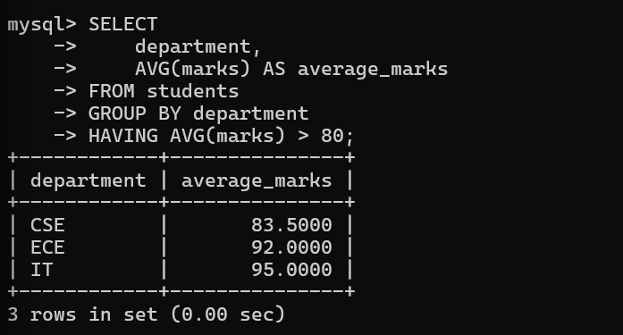
WINDOW FUNCTIONS
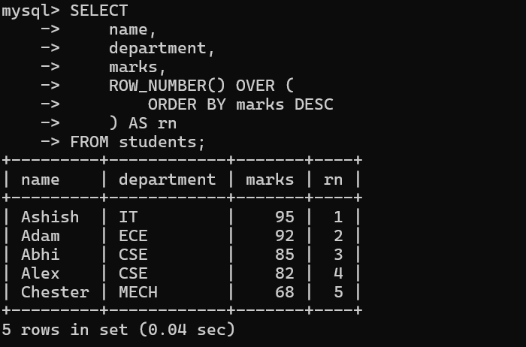
RANK()
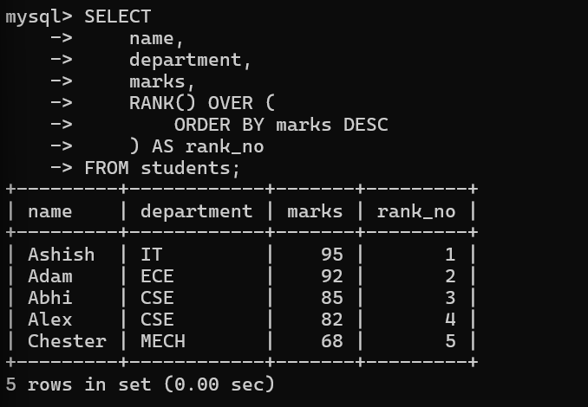
LAG()
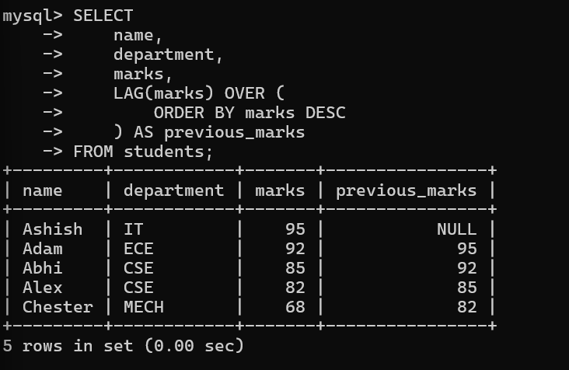
LEAD()
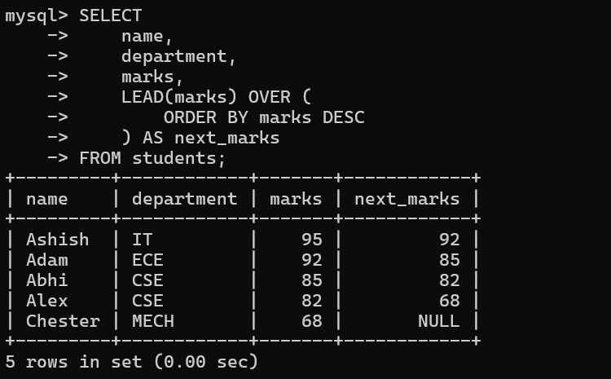
CASE EXPRESSIONS
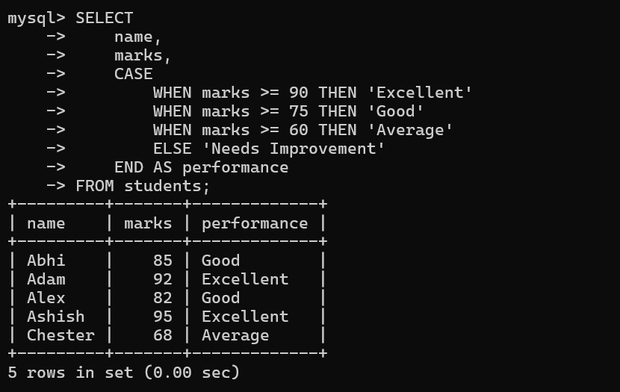
UNION
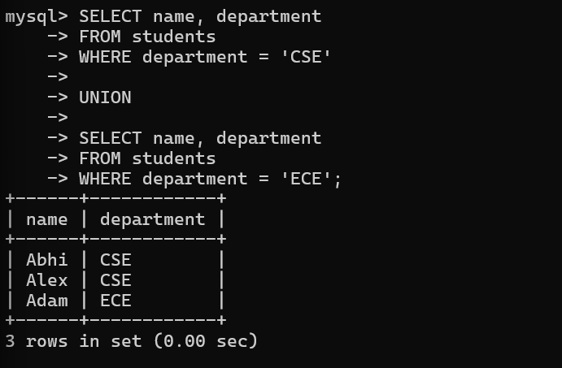
INTERSECT
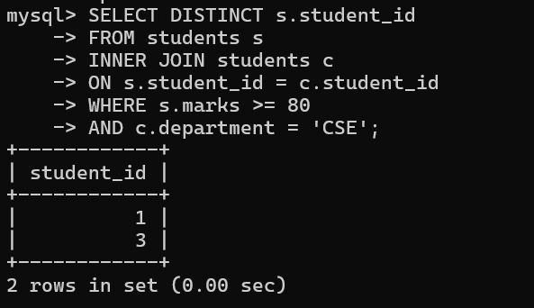
EXCEPT
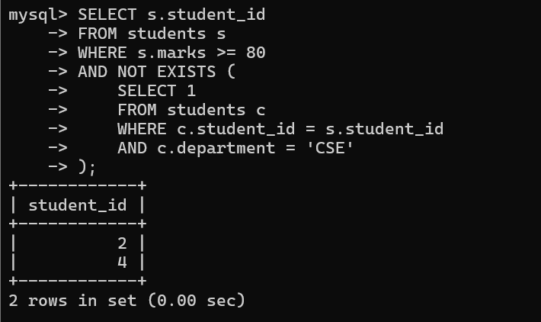
QUERY
- Query 1 — Display all students
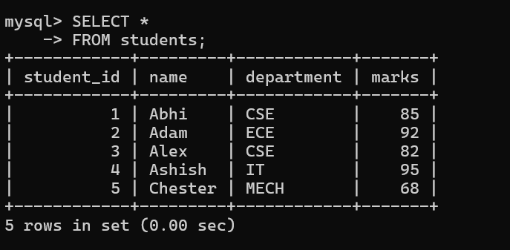
- Query 2 — Students scoring above 80
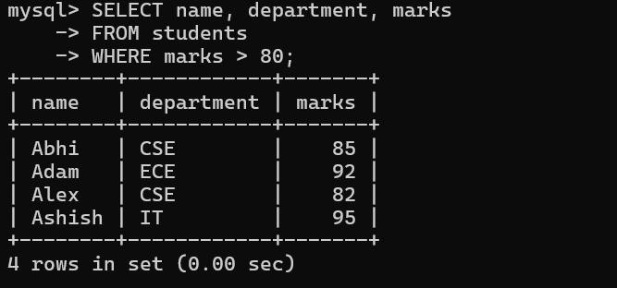
- Query 3 — Students from CSE
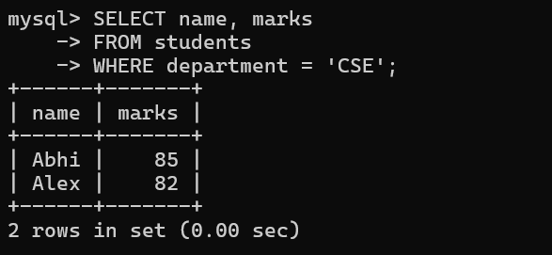
- Query 4 — Students from IT
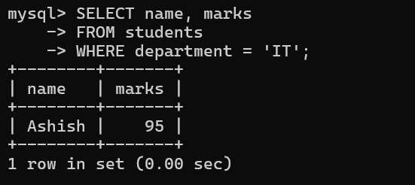
- Query 5 — Highest scorer
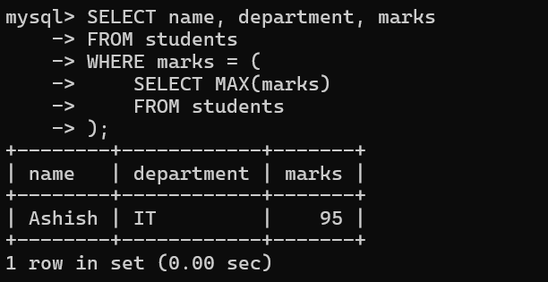
- Query 6 — Lowest scorer
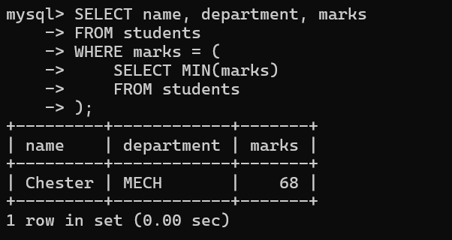
- Query 7 — Average marks
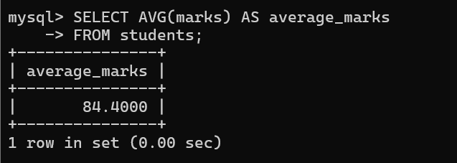
- Query 8 — Total number of students
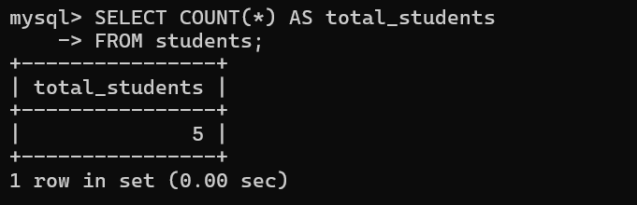
- Query 9 — Department-wise student count
- 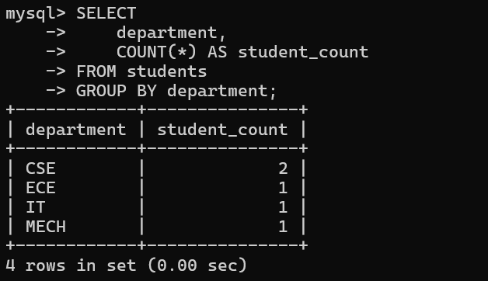
- Query 10 — Department-wise average
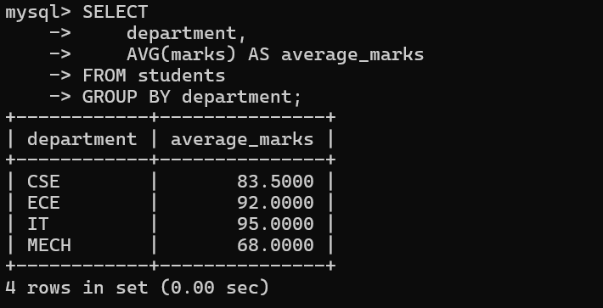
- Query 11 — Departments with average above 80
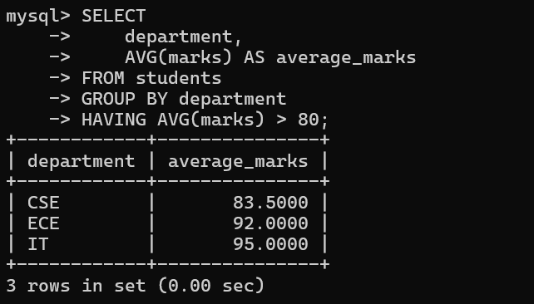
- Query 12 — Top 3 students
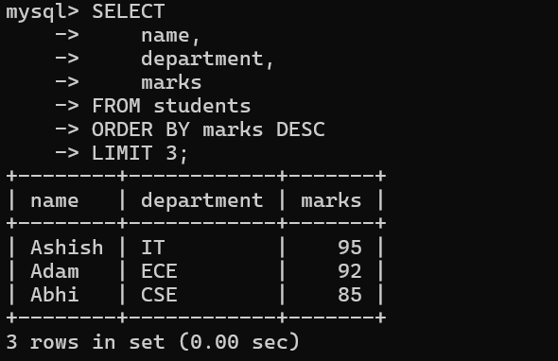
- Query 13 — Student performance category
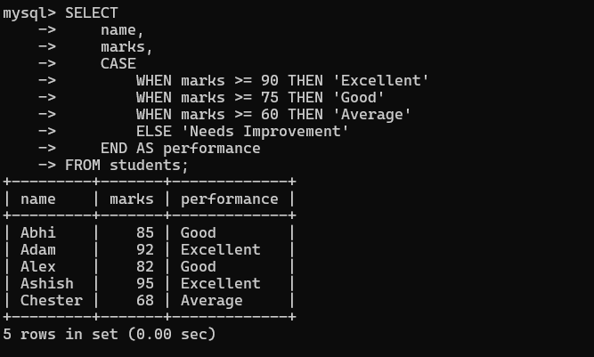
- Query 14 — Student ranking
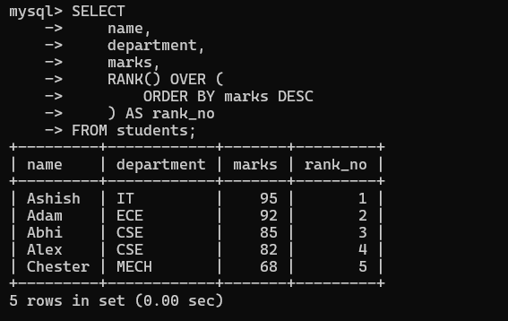
- Query 15 — Dashboard summary
